This example shows that there are 10 commits on GitHub that are not in my local repository on the desktop. To update this, click Pull Origin and my desktop folder will be updated.

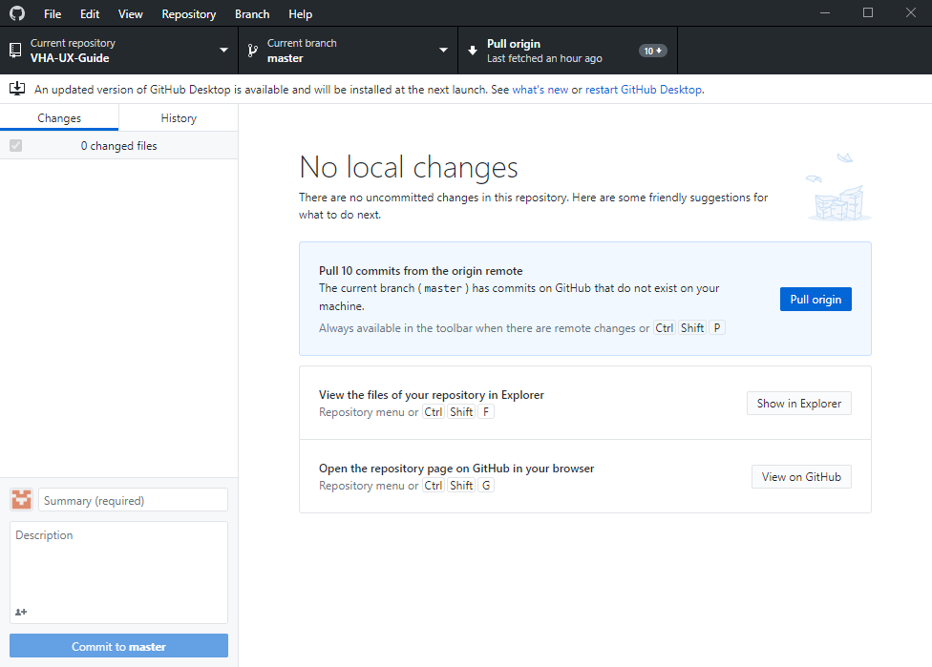

When you click the History tab in the left pane you will be able to see all of the changes that were made:

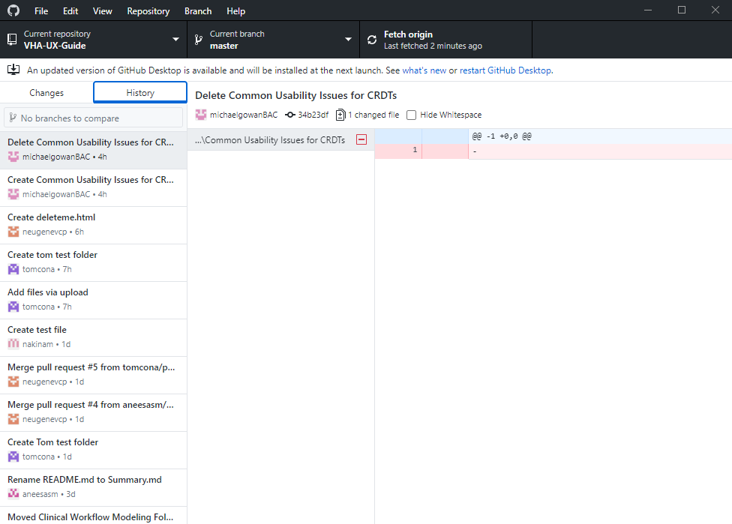

When you make changes in your GitHub folder on your local repository, they will show up in the left pane under the Changes Tab. I added a Test folder with a Test file inside. I will add a description for the commit in the bottom left pane, where it says “Create Test file. Pdf”. You must commit all changes before they are able to be pushed to the GitHub repository online. Click “Commit to master” and changes will be ready to push:

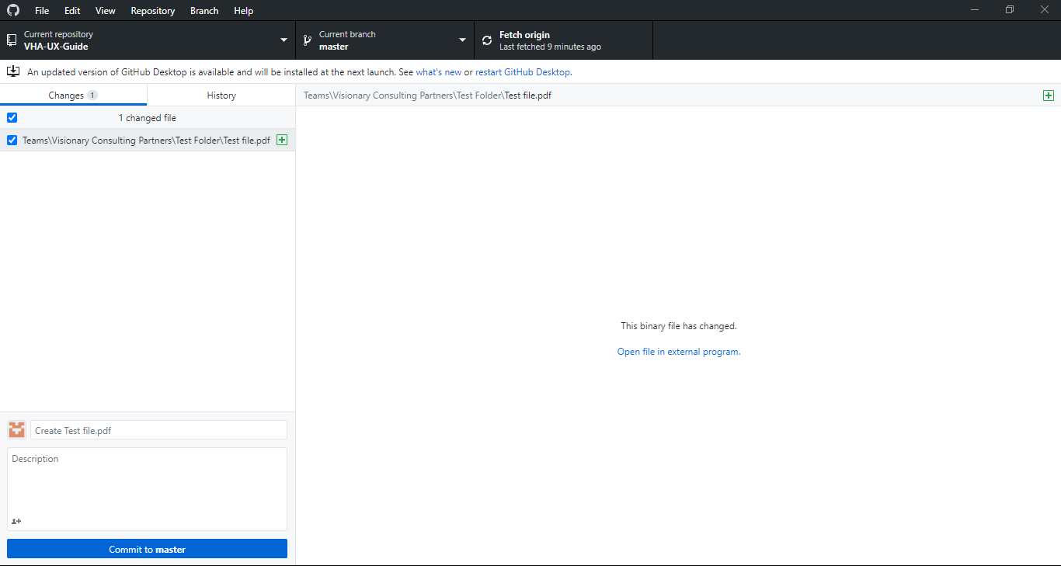

Notice that local changes are now ready to be pushed to the GitHub repository. It says that there is 1 local commit waiting to be pushed to GitHub. Click “Push origin”:

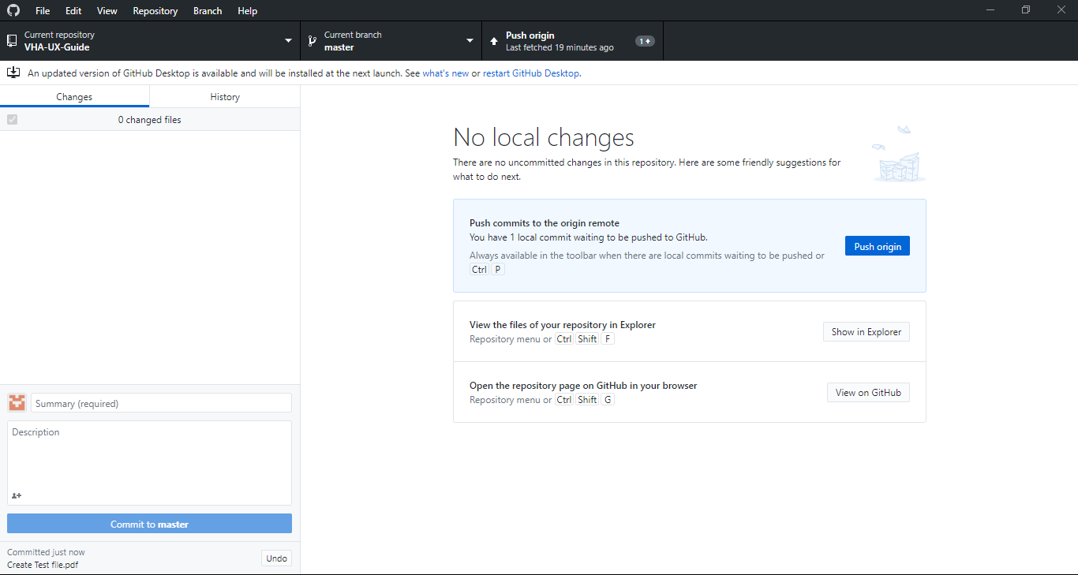

Click “Push origin”:  
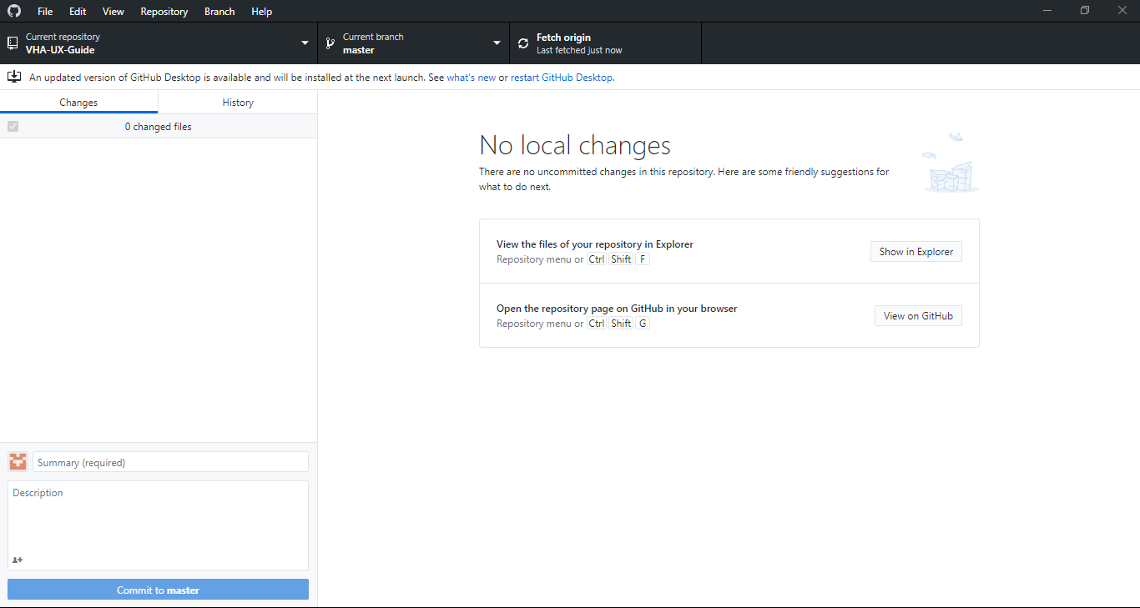

Notice that the Test Folder has been updated in the GitHub Repository:

